Are you looking for work from Feb until approximately June? Are you physically fit and enjoy working in a busy environment? We have lots of jobs available and the choice of three shifts.
Kiwifruit Packhouse – General Roles
Seasonal Casual & Fixed Term Employment

If you are reliable, have your own transport and enjoy a busy team environment then apply now!

We’re looking for people to work as:
- Packers – Final placement of fruit, wrapping and lidding of tray/box
- Grader – Carefully checking fruit to ensure it meets the required quality standards
- Stacker – Ensuring each box is labelled and placed on pallet. Requires a good level of fitness
- Tray preparation – Getting the kiwifruit trays ready and feeding them onto the packing lines
- Strappers – Moving pallets to and from the strapping machine using a pallet jack

You’ll get full training in any role you take on.

SHIFT DETAILS
Pick the days you want to work!
We will be running 12 hour shifts.
You can work either on day shift hours– working 6am until 6pm, or Night Shift Hours – working 6pm until 6am.
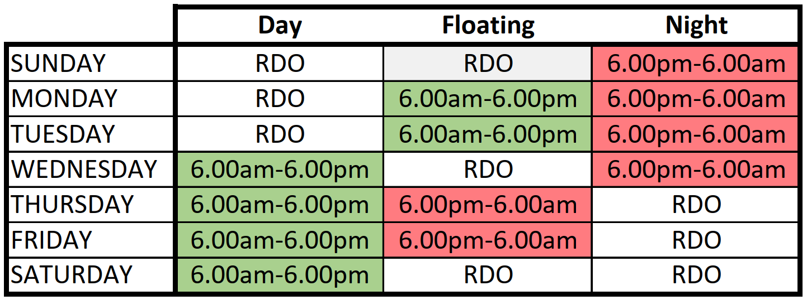

Our starting pay rate is $23 plus 8% holiday pay.
There are casual and fixed term opportunities.

ABOUT YOU
You will be:
- Physically fit and able to work on your feet
- A good communicator and able to speak and understand English
- Trainable and able to learn and follow instructions
- Reliable and punctual, with your own transport
- Legally able to work in NZ or hold an appropriate work visa
- Contactable by mobile phone and have access to Wi-Fi

ABOUT US
Here at Punchbowl, we have one mission and that is to grow greatness. We do this by growing and packing great fruit, investing in the community, and providing ways for our staff to grow and develop their careers. We value our people and believe that they are key to our success. We look for people who are aligned with our Company Values: Caring, Innovative, and Energetic. This is a unique opportunity to join a friendly and passionate team and get involved in a diverse and interesting industry.

